**©Topkina Holdings LTD**

# TOPKINA AGENCY

**Topkina Agency** was formed in 2008, This Entity mostly specializes in helping Bougainville though supplying goods and services provided by Major Companies like Swire Shipping, PNG Forest Products, and Trophy Haus.

The aim of this entity is to participate in rebuilding Bougainville through the supply of quality goods and services from major distributers throughout Bougainville.

### Sporting Equipment

We are one of the leading suppliers of Quality Sporting Equipment in the Autonomous Region of Bougainville. Sporting bodies and organizations from Bougainville come to us for sporting equipment’s Medals and Trophies. We have supplied sporting equipment’s together with Medals and Trophies for major sporting events in Bougainville.

|  |  |  |  |
| --- | --- | --- | --- |
| **Year** | **Event** | **Client** | **Budget** |
| **2010** | 3rd Kieta District Games | DCOD | K15,000 |
| **2010** | ABG Games Buin | Autonomous Bougainville Sports  Foundation (ABSF) | K33,000 |
| **2011** | South Bougainville  Pikinini Soccer | BUIN Community  Policing | K8,000 |

Page **21** of **28**

**©Topkina Holdings LTD**

|  |  |  |  |
| --- | --- | --- | --- |
| **2012** | Konnou Peace Games  Tabago | Hon Wilfred  Komba | K41,000 |

**PNG Air Agents**

We are also Agents for PNG Air in Central Bougainville. Passenger ticketing and handling of cargoes is coordinated by our team of 5 working staff from our office located inside hanger Tavern grounds and at Aropa airport.

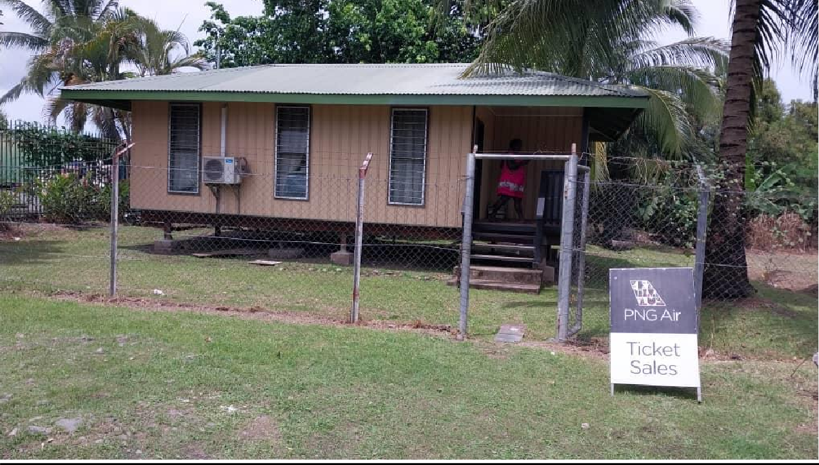

Page **22** of **28**

**©Topkina Holdings LTD**

## CONTACTS

|  |
| --- |
| **Head Office & Postal Address Section 15, Allotment 73, Arawa P O Box 218**  **Arawa,**  **Autonomous Region of Bougainville Email:** [**cpokona@gmail.com**](mailto:cpokona@gmail.com) |
| **Clarence Pokona – Director/General Manager P O Box 218, Arawa**  **Autonomous Region of Bougainville Digicel:7237 5548**  **Email:** [**cpokona@gmail.com**](mailto:cpokona@gmail.com) |
| **Elizabeth Anne Matsia Pokona – Admin Manager P.O.Box 218, Arawa**  **Autonomous Region of Bougainville Digicel:73675708**  **Email: N/A** |
| **Bankers**  **Bank of South Pacific (BSP) Branch: Buka / Arawa**  **Topkina Holdings ltd has existing Bank Account with BSP Bank.** |

Page **27** of **28**

**©Topkina Holdings LTD**

Page **28** of **28**